Practical 14

Part A:
Aim:
1. Assemble and test: build a tiny layered app (a model, a service using an ArrayList, and a menu main), then write two or three JUnit @Test methods checking that adding increases the count and an invalid action throws — practice before testing MiniBank.

Code:
Task.java

public class Task {
private final int id;
private final String description;

public Task(int id, String description) {
if (id <= 0) {
throw new IllegalArgumentException("Task ID must be positive");
}

if (description == null || description.isBlank()) {
throw new IllegalArgumentException(
"Task description cannot be empty");
}

this.id = id;
this.description = description;
}

public int getId() {
return id;
}

public String getDescription() {
return description;
}

@Override
public String toString() {
return id + ". " + description;
}
}

TaskService.java

import java.util.ArrayList;
import java.util.List;

public class TaskService {
private final List<Task> tasks = new ArrayList<>();
private int nextId = 1;

public Task addTask(String description) {
Task task = new Task(nextId++, description);
tasks.add(task);
return task;
}

public int getTaskCount() {
return tasks.size();
}

public List<Task> getAllTasks() {
return new ArrayList<>(tasks);
}

public void removeTask(int id) {
boolean removed = tasks.removeIf(task -> task.getId() == id);

if (!removed) {
throw new IllegalArgumentException(
"Task ID not found: " + id);
}
}
}

TaskApp.java

import java.util.Scanner;

public class TaskApp {
public static void main(String[] args) {
TaskService service = new TaskService();

try (Scanner scanner = new Scanner(System.in)) {
boolean running = true;

while (running) {
System.out.println("\n--- Task Manager ---");
System.out.println("1. Add task");
System.out.println("2. View tasks");
System.out.println("3. Remove task");
System.out.println("4. Exit");
System.out.print("Choose an option: ");

String input = scanner.nextLine();

try {
switch (input) {
case "1" -> {
System.out.print("Enter description: ");
Task task = service.addTask(scanner.nextLine());
System.out.println("Added: " + task);
}
case "2" -> {
if (service.getAllTasks().isEmpty()) {
System.out.println("No tasks available.");
} else {
service.getAllTasks()
.forEach(System.out::println);
}
}
case "3" -> {
System.out.print("Enter task ID: ");
int id = Integer.parseInt(scanner.nextLine());
service.removeTask(id);
System.out.println("Task removed.");
}
case "4" -> running = false;
default -> System.out.println("Invalid menu option.");
}
} catch (IllegalArgumentException e) {
System.out.println("Error: " + e.getMessage());
}
}
}

System.out.println("Goodbye!");
}
}

Output:
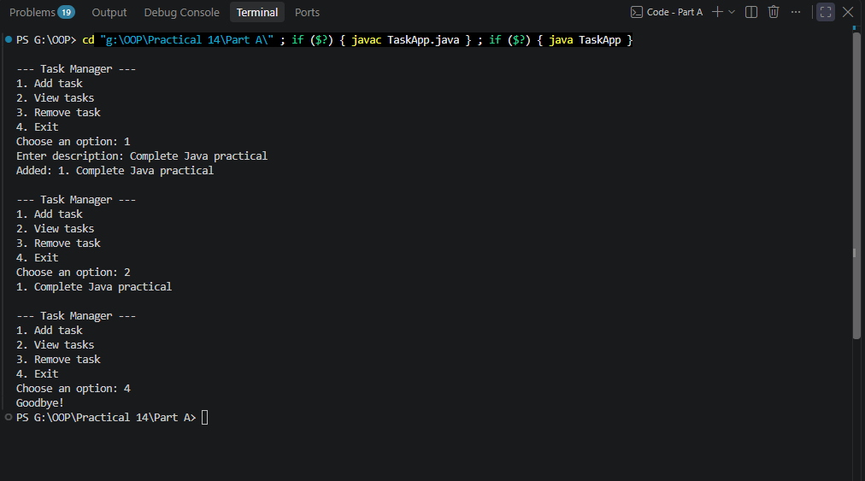

2. (For Advanced Learners – home) Organise that app into packages, build a runnable JAR, and add a test that saves and reloads its data unchanged.

Code:
Pom.xml

<project xmlns="http://maven.apache.org/POM/4.0.0"
xmlns:xsi="http://www.w3.org/2001/XMLSchema-instance"
xsi:schemaLocation="http://maven.apache.org/POM/4.0.0
https://maven.apache.org/xsd/maven-4.0.0.xsd">

<modelVersion>4.0.0</modelVersion>

<groupId>lab.tasks</groupId>
<artifactId>task-manager</artifactId>
<version>1.0.0</version>

<properties>
<maven.compiler.release>21</maven.compiler.release>
<project.build.sourceEncoding>UTF-8</project.build.sourceEncoding>
<junit.version>5.11.4</junit.version>
</properties>

<dependencies>
<dependency>
<groupId>org.junit.jupiter</groupId>
<artifactId>junit-jupiter</artifactId>
<version>${junit.version}</version>
<scope>test</scope>
</dependency>
</dependencies>

<build>
<plugins>
<plugin>
<groupId>org.apache.maven.plugins</groupId>
<artifactId>maven-surefire-plugin</artifactId>
<version>3.5.2</version>
</plugin>

<plugin>
<groupId>org.apache.maven.plugins</groupId>
<artifactId>maven-jar-plugin</artifactId>
<version>3.4.2</version>
<configuration>
<archive>
<manifest>
<mainClass>lab.tasks.TaskApp</mainClass>
</manifest>
</archive>
</configuration>
</plugin>
</plugins>
</build>
</project>

Key Questions / Analysis / Interpretation to be evaluated during/after Implementation

1. What is a layered architecture (model, service, user interface), and why is it useful?

Ans.
Layered architecture organizes an application into separate layers, each with a specific responsibility.
Layer | Responsibility | Example in Task Manager
Model | Represents and stores data | Task.java
Service | Implements business logic and manages operations | TaskService.java
User interface | Accepts user input and displays results | TaskApp.java
Why is it useful?
- Separation of concerns: Each layer has a clear responsibility.
- Maintainability: Changes to one layer usually require fewer changes to others.
- Testability: The service can be tested independently of the user interface.
- Reusability: The same service can be used by a console application, a web application, or another interface.

2. How do you assert in JUnit that a method throws an expected exception?

Ans.
Use JUnit 5's assertThrows() method. It verifies that the specified exception type is thrown when the tested operation executes.
Syntax:
assertThrows(
IllegalArgumentException.class,
() -> service.removeTask(999)
);
Here, the test passes if removeTask(999) throws an IllegalArgumentException, as expected when task ID 999 does not exist.

3. What does packaging the application as a runnable JAR provide?

Ans.
A runnable JAR packages compiled Java classes and application resources into a single Java Archive file. Its manifest specifies the main class that should execute when the JAR is launched.
Advantages:
- Portability: The application can be distributed as one archive.
- Easy execution: Run it using java -jar filename.jar.
- Simplified deployment: Users do not need to compile the source code again.
- Organization: Compiled classes and resources are packaged together.

